Asynchronous Calls

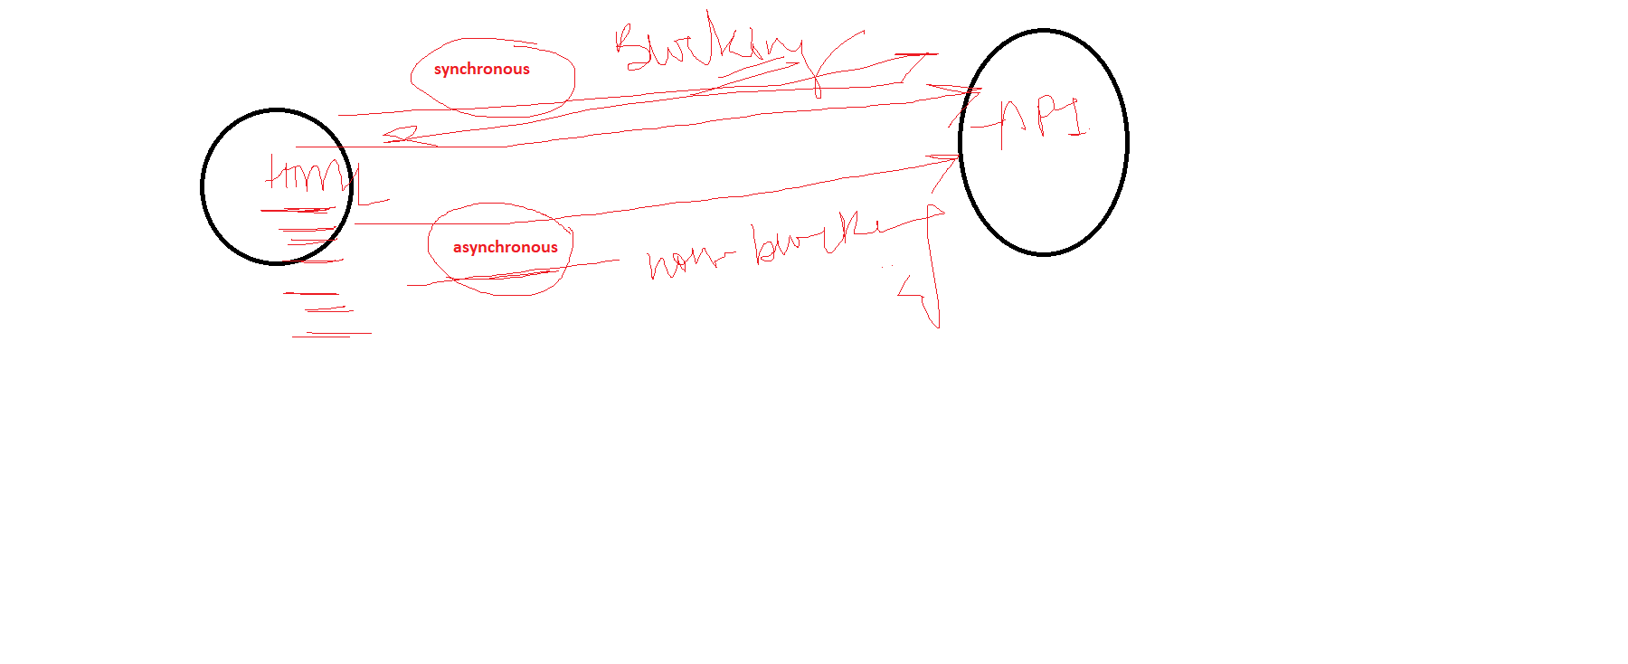

Callback Methods

It is method in which we pass some other method as a argument

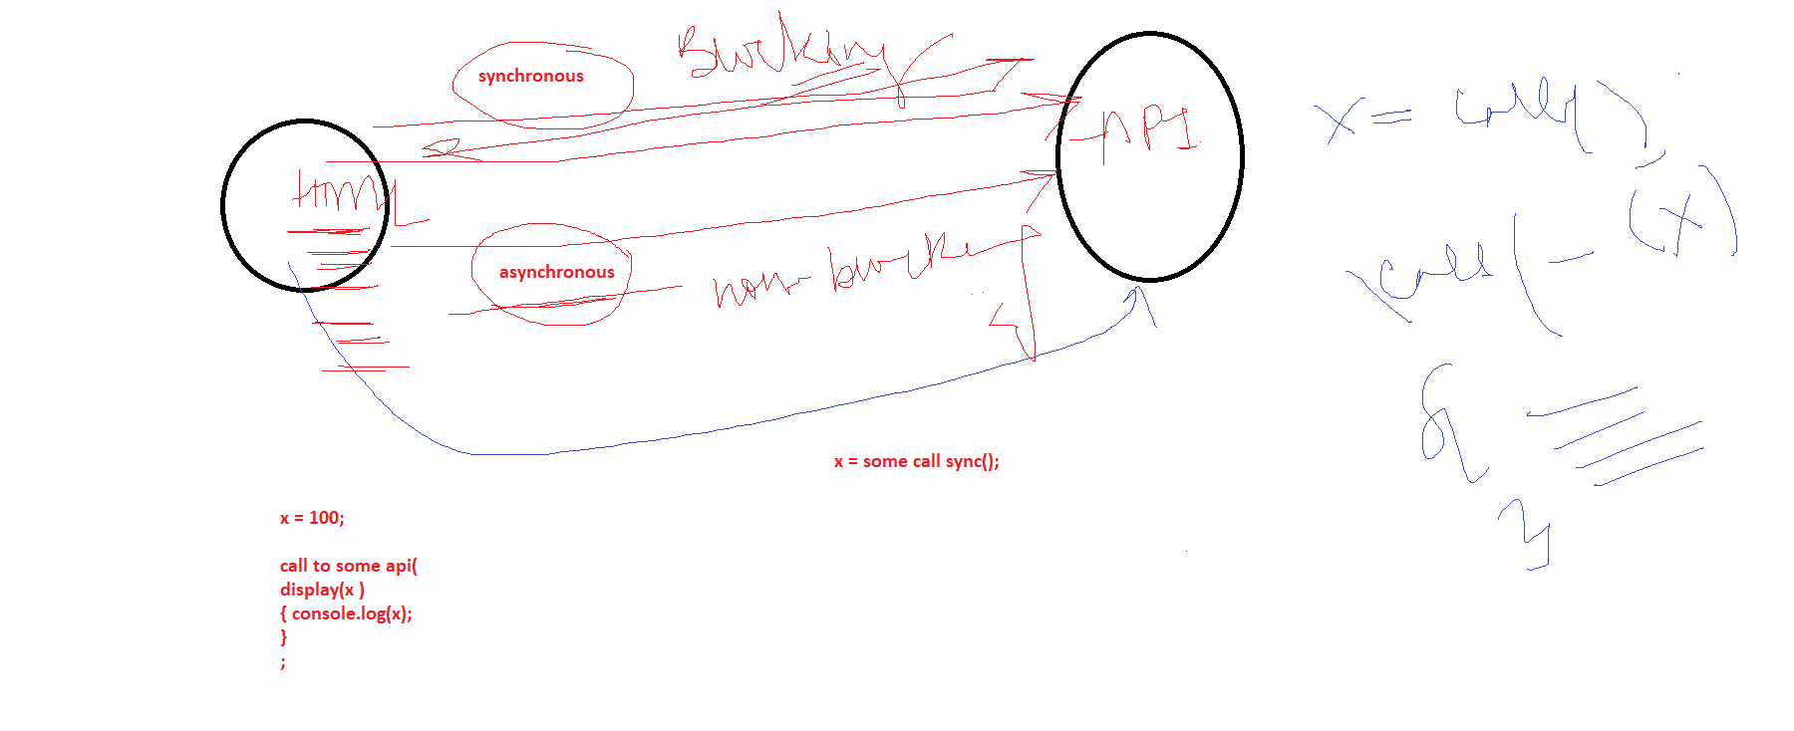

When you make call to a service in async mode, that service cud take some time, whenever the response will come, callback method is called

Try

{

Call to some service

}

Catch(exec ex)

Callback method

Int sum = add(9,8); // sync call

Console.log(sum);

Add(9,8).then(sum) => console.log(sum);

Add(9,8).then(function (res)

{

}

.catch(ex e)

Different ways in which we make async calls and every way is simpler than the prev way

1. XMLHttpRequest Object (xhr) is available in JS
2. Fetch Api
3. Promise
4. Async await

CallBack Methods will be used in all these ways